###### *St Pius X Catholic Parish Heidelberg West acknowledges the Wurundjeri people*.

Fr Wayne Edwards: St Pius X Presbytery 419 Waterdale Rd Heidelberg West 3081

Tel: 9457 5794 Fax: 9457 1036 Email: heidelbergwest@cam.org.au

Exodus Community: 273 Liberty Parade Heidelberg West Tel: 9457 7593

School Principal: Barbara Gomez Tel: 9457 3776 Email: bgomez@spxhw.catholic.edu.au

_________________________________________________________________________________________________

MASS TIMES

Sundays Saturday Vigil 7pm Sunday 9am & 11.00am

Exodus Community, 12 Noon in the shed at 273 Liberty Pde, Heidelberg West

Weekdays 9am Tuesday, Wednesday, Thursday, Friday, Saturday

CONFESSIONS & ROSARY After 9am Mass on Saturday mornings

CHURCH OPEN FOR PRAYER 8.30am – 4pm on school days only

PARISH WEBSITE - pol.org.au/heidelbergwest

*St Pius X Catholic Church Heidelberg West actively works to listen to, empower and protect children, and has zero tolerance for child abuse and neglect*.

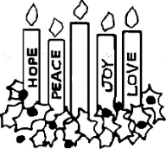**LIGHTING THE ADVENT WREATH 4TH WEEK**

As all four candles are lit to symbolize **HOPE, PEACE, JOY and LOVE**,we join in saying,

**‘O Wisdom, holy Word of God, Jesus**

**CHRISTMAS RAFFLE TICKETS**

Tickets are on sale at all Masses for $1.00 a ticket. Thank you for your support. Raffle will be drawn after 11am Mass this Sunday

***Reflection:*** *“For behold, when the voice of your greeting came to my ears, the babe in my womb leaped for joy.”  (LUKE 1:44)*

When you hear the scripture readings and Gospel reading at Mass, do you “leap for joy?”  If not, don’t blame the lecturer or priest, rather look inside yourself.  What are you doing to grow in friendship with Jesus?  How do you prepare for Mass each week?  Or, do you just show up and expect to be entertained?  As the Body of Christ, we are called to be active participants, not just passive observers.

**Next Sunday**: December 26th

|  |  |  |
| --- | --- | --- |
|  | **Reader** | **Special Ministers** |
| Saturday 7:00pm | Margaret Scroggie |  |
| Sunday 9:00am | Caroline Sheehan |  |
| Sunday 11:00am | Valerie Lennox |  |

**NEXT SUNDAY’S READINGS – THE HOLY FAMILY OF JESUS MARY AND JOSEPH** 1 Sam 1: 20-22, 24-28; Ps 83: 2-3, 5-6, 9-10; 1 Jn 3: 1-2, 21-24

**EXPERIENCE TAÍZÉ Friday, 31 December, 6pm-7pm at St Pius X Church**

Come and experience this calming, quieting, welcome respite from the hustle and bustle of life…. All are welcome!

**CHRISTMAS MASSES VOLUNTEERS**

Volunteers to read and be special ministers are needed for the **Christmas Eve 6pm** and **Midnight Masses** and **Christmas Day 10am** Mass. Thank you!

**WEEKLY REFLECTIONS FOR THE SEASON OF ADVENT**

These weekly reflections have been prepared with the gospel readings for each Sunday of Advent and offer an opportunity for individuals and/or groups to read, reflect, pray and act prompting each one of us to go out into the waiting time of Advent and express the god-within-us to others.

<https://melbournecatholic.org/uploads/documents/The_Grace_of_WaitingAdvent_2021.pdf#asset:244631>

**ST PIUS X GIVING TREE TO SUPPORT ST VINCENT DE PAUL**

C:\Users\Parish\AppData\Local\Microsoft\Windows\Temporary Internet Files\Content.IE5\Q7UQF7TR\MC900410591[1].wmf Please support our Giving Tree again this year, which assists St Vincent de Paul here in Heidelberg West. You are invited to purchase non-perishable goods for hampers for those in need in our local area. New toys for children are also welcome!

***Prayers for the Sick***; David Tickner, Pauline Curlis, Joy Opie, Rosemary Alfred

***For the Recently Departed****: For the repose of all the sous of the faithful departed*

***Anniversary of Death***: Joseph Patrick Pitts, Joseph Francis Pitts, Albie McGorlick, Claire, Ron & Robert Oldroyd,

**DONATIONS THROUGH CDF PAY - QR CODE**

*This St Pius X CDFPay QR CODE enables you to make quick and easy online thanksgiving payments – you can set up a recurring payment, or you can choose a one-off offering to your parish or presbytery account.*

*Thank you for your ongoing support of our Church*

**Christmas Eve Friday, 24 December**

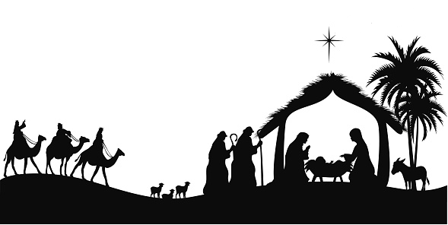**6pm** Family Mass

**12am** Midnight Mass

**Christmas Day**

**10am Mass on Saturday, 25 December**

**New Year’s Day**

**10am Mass on Saturday, 1 January**

Solemnity Mary Mother of God